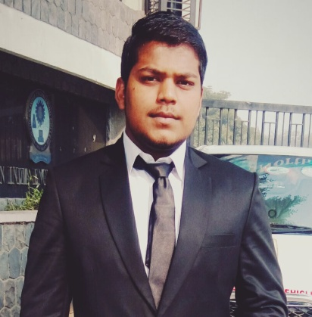
SHUBHAM GUPTA
Email ID – Shubham.gupta714@gmail.com
Mobile - +91-8010284242

Career Objective
To be involved in your firm and excel through constant hard work and dedication. Being endowed with the traits of strong willpower and patience I want to achieve a sustained platform in the field of Purchase by developing myself as a person of multidisciplinary approach.
Academic detail
Qualification | Board/University | Year | Percentage (%)
B-Tech (Mechanical&Automation Engineering) | GURU GOBIND SINGH INDRAPRASTHA UNIVERSITY (NORTHERN INDIA ENGINEERING COLLEGE , Delhi) | 2013-2017 | 68.4
Intermediate | Central Board of Secondary Education (Army Public School, Delhi Cantt.) | 2013 | 71.2
High School | Continuous and Comprehensive Evaluation (Rainbow English Sr. Sec. School, Janakpuri, Delhi) | 2011 | CGPA-9  90

experience
Organization - MUNJAL AUTO INDUSTRIES LTD. (Dharuhera ,Haryana)
Designation - Engineer (Purchase Department)
Duration - 4th Sept 2017 Till Present

“Munjal Auto Ind. Ltd. Dharuhera, Haryana”
Munjal Auto Industries Ltd. (MAIL) is anISO/TS 16949:2009 accredited, leading auto component manufacturing company in INDIA. Producing Exhaust systems for two wheelers and four wheelers, Spoke rims for two wheelers, steel wheel rims for two wheelers and four wheelers , Fuel tank for four wheeler , Seat frame for four wheelers and other automotive assemblies.
The company holds the pride of being among the Largest manufacturer of the Exhaust systems in the world, manufacturing close to 26,000 systems per day.
The Company is Tier1 supplier of exhaust system to HERO MOTOCORP LTD.
job profile
- Good Exposure of Mechanical equipment’s , Electrical components , Tool fixture
- Good in sourcing of material.
- Handling Consumable , Negotiation part and supplier management
- Purchase Order and Material Code opening in SAP.
- Follow up with Accounts to paid timely to the suppliers for Good relationship .
- Gained knowledge of BOP Purchase in Training Period.
- Knowledge of Part Cost & Cost Reduction.
- Handled vendors for BOP.
- Created and maintained documentation.
- Developed project and identified ways for reducing cost of plant.
- Vendor Management .
- New Vendor development .
Internship
Organization - Sikka Automobile Pvt. Ltd (HYUNDAI) Duration -(6TH July’16 – 5TH Aug’16) Nature Work – Trainee Learning – To understand the complexity of the problems faced by the four wheelers and to solve it’s complexities. Location- MayapuriIndustrial Area , New Delhi
IT Skills
- Languages known – C++/C
- Software - SAP
Academic Project(s) Undertaken
- INTERNATIONAL GOKART CHAMPIONSHIP held in LPU, Jalandhar (27th March 2015-30th March 2015).
(Role- Looking after Marketing & Braking Department)
- SUPRA SAEINDIA FROMULA held in Chennai (16THJuly 2015– 19TH July 2015).
(Role- Looking after Braking department)

Achievements
- Senior Coordinator of ECELL NIEC& Awarded for the BEST ECELL SOCIETY.
- Coordinated E-SUBMITT 2K16 held on 9th Feb, 2016 at NIEC.
- Coordinated INTERNSHIP FAIR 2K16 held on 2nd April, 2016 at NIEC.
- Worked as an Intern in HR/Admin Department in a NGO (SAPNE) from Dec 2016- Feb 2017.
INTERPERSONAL SKILL
- Ability to rapidly build relationship and set up trust.
- Confident and Determined.
- Ability to cope up with different situations.
- Presentation Skills , Client Relationship, Negotiation .
PERSONAL DETAILS
Year of Birth: 1995
Languages Known: English, Hindi
Permanent Address: WZ-468 C/2 MS BLOCK HARI NAGAR NEW DELHI-110064
Hobbies & Interests: Listening Songs, Exploring new places with friends.

